1. First, we created the Zod validation in the validators file

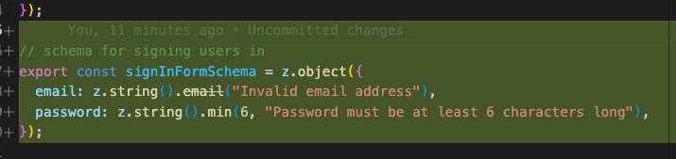

1. Then we created user actions

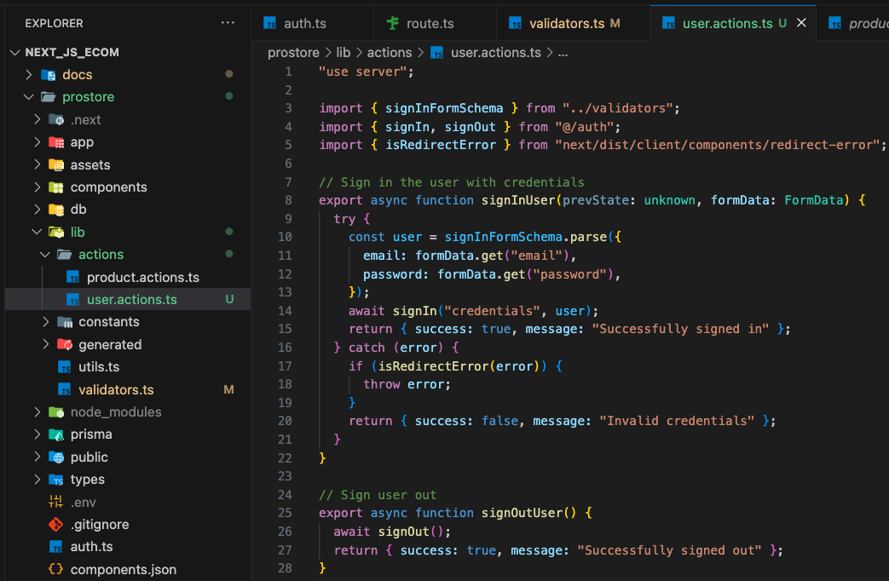

**prevState: unknown**

The prevState parameter is a convention used in Next.js Server Actions, specifically when using the useFormState hook from React. It represents the previous state of the form. When the form is submitted for the first time, prevState is undefined. After the action runs and returns a new state, useFormState updates and passes that new state back to the action on the next submission.

The type unknown is used because the shape of the previous state is determined by what the action itself returns. It could be an object with a success and message property, or something else entirely. Using unknown provides flexibility and forces developers to perform type checks or assertions before using the value, which is a good practice.

**Redirection Error**

The redirection error is thrown by Next.js when a Server Action needs to redirect the user to a new page. This is often done after a successful operation, like a sign-in. The signIn function from NextAuth.js (used in the code) performs this redirection internally.